 

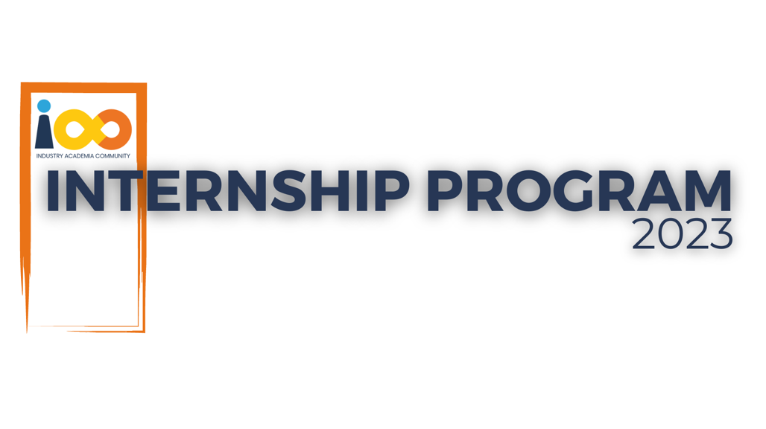

PROJECT REPORT

PYTHON DOMAIN

COMPREHENSIVE ANALYSIS OF STUDENT INTERNS

|  |  |  |  |
| --- | --- | --- | --- |
| **Created By:** | Shagun mishra | **Approved By:** | Suraj mane sir |
| **Created On:** | 25-09-2023 | **Approved On:** | 20-08-2023 |

**IAC – IP: Live Project Report** 

INDEX

**2** **PROJECT DETAILS** 3

**3** **SUMMARY** 3

**4** **INTRODUCTION** 4

4.1 Background 4

3.2 Stakeholders 5

4.3 Objectives 5

**4. METHODOLOGY** 6

4.1 Considerations & Assumption 6

4.2 Approach 7

4.3 Activities 7

**5** **TARGETTED V/S ACHIEVED OUTPUT** 8

**6. CONCLUSION** 9

**7. APPENDICES** 10



# **PROJECT DETAILS**

|  |  |  |  |
| --- | --- | --- | --- |
| **Project Name** | Comprehensive analysis of student interns | | |
| **Project Sponsor** | Harshada Topale | | |
| **Project Manager** | Harshada Topale | | |
| **Start Date** | 1-08-2023 | **Completion Date** | 30-09-2023 |

# **SUMMARY**

The project was expected to deliver the student information so that the organization could find the status of the particular student based on their performance. Based on the performances of students organizations can easily select their candidates. But for this, the required data of all the students is needed to extract the information based on this information it becomes easier to understand the current status of the student on the basis of attributes that were given the dataset so that in future, it can be easy to take decisions by comparing it with the past performance.

# **INTRODUCTION**

In this following project, to do the analysis process we have given a dataset to get meaningful information from the data and through the data cleaning and manipulation with the help of the Python libraries we can easily get the required information from the given dataset. By doing all the analysis processes, the conclusion will be made based on these analysis processes of the data.

## Background

In this project, we want to extract the information of students and for this, we have used Python as a base and different visualization tools to fetch that information from the given data so that we can analyse the performance of each student and make some decisions about the current performance of each student.

## 3.2 Stakeholders

With the guidance of the project managers like Suraj Mane sir and other mentors, the project was delivered in a meaningful way which also helped me to learn various methods to accomplish the tasks. According to the requirements of our mentors, we have fully tried to deliver it in a structured manner. With the guidance of all the project managers and team leaders, we have achieved the outcome of the project that is achieving the analysis process. At last, in the completion of the project, all the mentors and leaders have helped and motivated us to achieve the objective of the project.

## Objectives

To get the information about the student interns through comprehensive analysis the relationship between all the attributes is determined in the given data. By using different tools and methods we are able to determine student performance. Through this analysis process, it becomes easier to estimate the student performance based on their data and how it will be in future we have extracted some required information from the data. The main goal behind this project is to do the analysis on the given dataset and make decisions regarding student performance.

# **4. METHODOLOGY**

In the methodology, we have followed some approaches for the analysis process like the libraries that we are going to use in this project and with this, some of the activities are performed in this project to accomplish our project in a structured way that can easily help us to achieve of the outcome of the project

## 4.1 Considerations & Assumption

In this project, there is no use of Front-end languages like HTML, CSS etc. and in this project, we haven’t used machine learning for the analysis process using the simple Python tool we can achieve the outcome of our project. Challenges are finding the relationship between the attributes and the assumptions that we made to use the visualization libraries to gather more information from the given data. Making the targeted outcome similar to the achieved outcome is another challenge for us in this project.

## 4.2 Approach

In this project, our main objective is to do a comprehensive analysis on the basis of the given dataset. By going through the dataset it is easier to understand the requirement of the data and on the basis of the requirement we have planned and designed the process like the dataset was not cleaned so through the data cleaning process we have cleaned our dataset using imported libraries of the python and with these libraries we have done some visualization to understand more about the data so that it will be easier to obtain the required outcome from this project.

## 4.3 Activities

Activities that are performed in this project are First is a requirement in the first process platforms like jupyter notebook (python) RAM- 8.00 GB is used. Second is planning, in this process using some of the libraries we have to perform a comprehensive analysis. Third is the design phase, in this, we have imported the libraries and then we have performed all the analysis processes based on the dataset that is given to us. Fourth is the development phase, in this process data cleaning, manipulation, etc. is done to extract the required information and to find out the relation between all the attributes and some insights from the data we have cleaned the data after that to solve the particular statement we have used different approaches like various libraries using python. Fifth is the testing process, in this process by the analysis of the data we have identified whether the achieved outcome of the data is similar to the targeted outcome or not. The last process is, deployment and in this phase through the various visualization libraries with the data cleaning and manipulation technique we gathered the information from the data.

# **TARGETTED V/S ACHIEVED OUTPUT**

The target output of this project was to do a Comprehensive analysis of the interns so that on the basis of their performance interns would get selected for the particular position. Achieved output is we get the relationship between the attributes and it shows the max. Number of students attending the particular events and shows the variation between each individual performance of student interns.

# **6. CONCLUSION**

It will be useful for the stakeholders as it will help to apply different methodical approaches for the given problem statements using various tools and technologies. In the future, when there is a need to obtain the data of all the students then it becomes easier for all the stakeholders or the other people to make decisions based on the past performance of each student intern. By doing the analysis process it makes us aware of each student's performance on the basis of certain attributes so that in the near future, by implementing new methods and tools we can easily extract the information from any given data and the future scope of this project will help to find out the all the useful information from the data and will also help all the stakeholders to make any strategic decisions.

# **7. APPENDICES**

1. PROJECT DETAILS
2. SUMMARY
3. INTRODUCTION
4. Methodology
5. TARGETTED VS ACHIEVED OUTPUT
6. CONCLUSION